Final Project

System Design Proposal

Team Ultimate

November 17th 2016

**Introduction:**

Iowa State’s MyState app design has too many menus and features which makes it difficult for first time user to find information they need and also takes longer time for current students to access information. Team Ultimate believes students want information about the weather, upcoming sporting events, and buses that are going to arrive nearby, in a quick, concise manner without all the extra clutter.

Iowa State Information Technology Services will be our business client and our final product would be as deployed as a small desktop widget that would be installed by the IT services on all school desktops. No foreseeable compatibility issues would arise because our desktop GUI will be small and presentable and would not be interfering with other programs on the systems. The desktop widget will always be displayed behind all other windows and tasks. Any program that is open will be displayed in front of this widget, making the widget less obnoxious.

**Business Opportunity**

In today's modern world of smartphones and web-based calendars, our application will attempt to provide a quick and easy way for people to view Iowa State event information in a clean, easy to read, and customizable way. Iowa State IT service uses Dell brand desktops on most school computers in the libraries or the labs except when the particular room require other operating systems such as OSX in which case the Windows OS is also installed. This would make it less time consuming for us to develop a product that will be used across Iowa State’s computers without having compatibility issues.

While we understand that the nature of a desktop application prevents it from being the best way for students to view this kind of data on the go, we believe that our application could in theory be utilized as a pre-installed lightweight app that is readily available on every university-owned computer on campus. This tackles the issue that would plague most desktop applications when comparing them to their web-based counterparts. Nobody wants to install an application when they can just click a link and go to a website, but on university computers, installations are handled by ITS.

**Advantages**

The main advantage of our application is providing users of university-owned computers on campus with a way to easily browse upcoming events on campus from a slicker and easier to use interface. ITS would be able to offer this program as a resource to students with no added work for students. This application could be expanded over time to include more helpful features that students might be able to utilize on campus.

**Modules:**

Main_Interface: The main_interface will build up the structure of the application and connect the Weather, Bus, Sports and News.

Weather: Provides the weather information in Ames

Bus: Provides the Bus information by entering the stops

Sports: Provides the sports schedule and the weather information of the place.

News: Provides the current News with the links that people can browse to the actual website.

**Proposed Functionality**

Main_Interface: 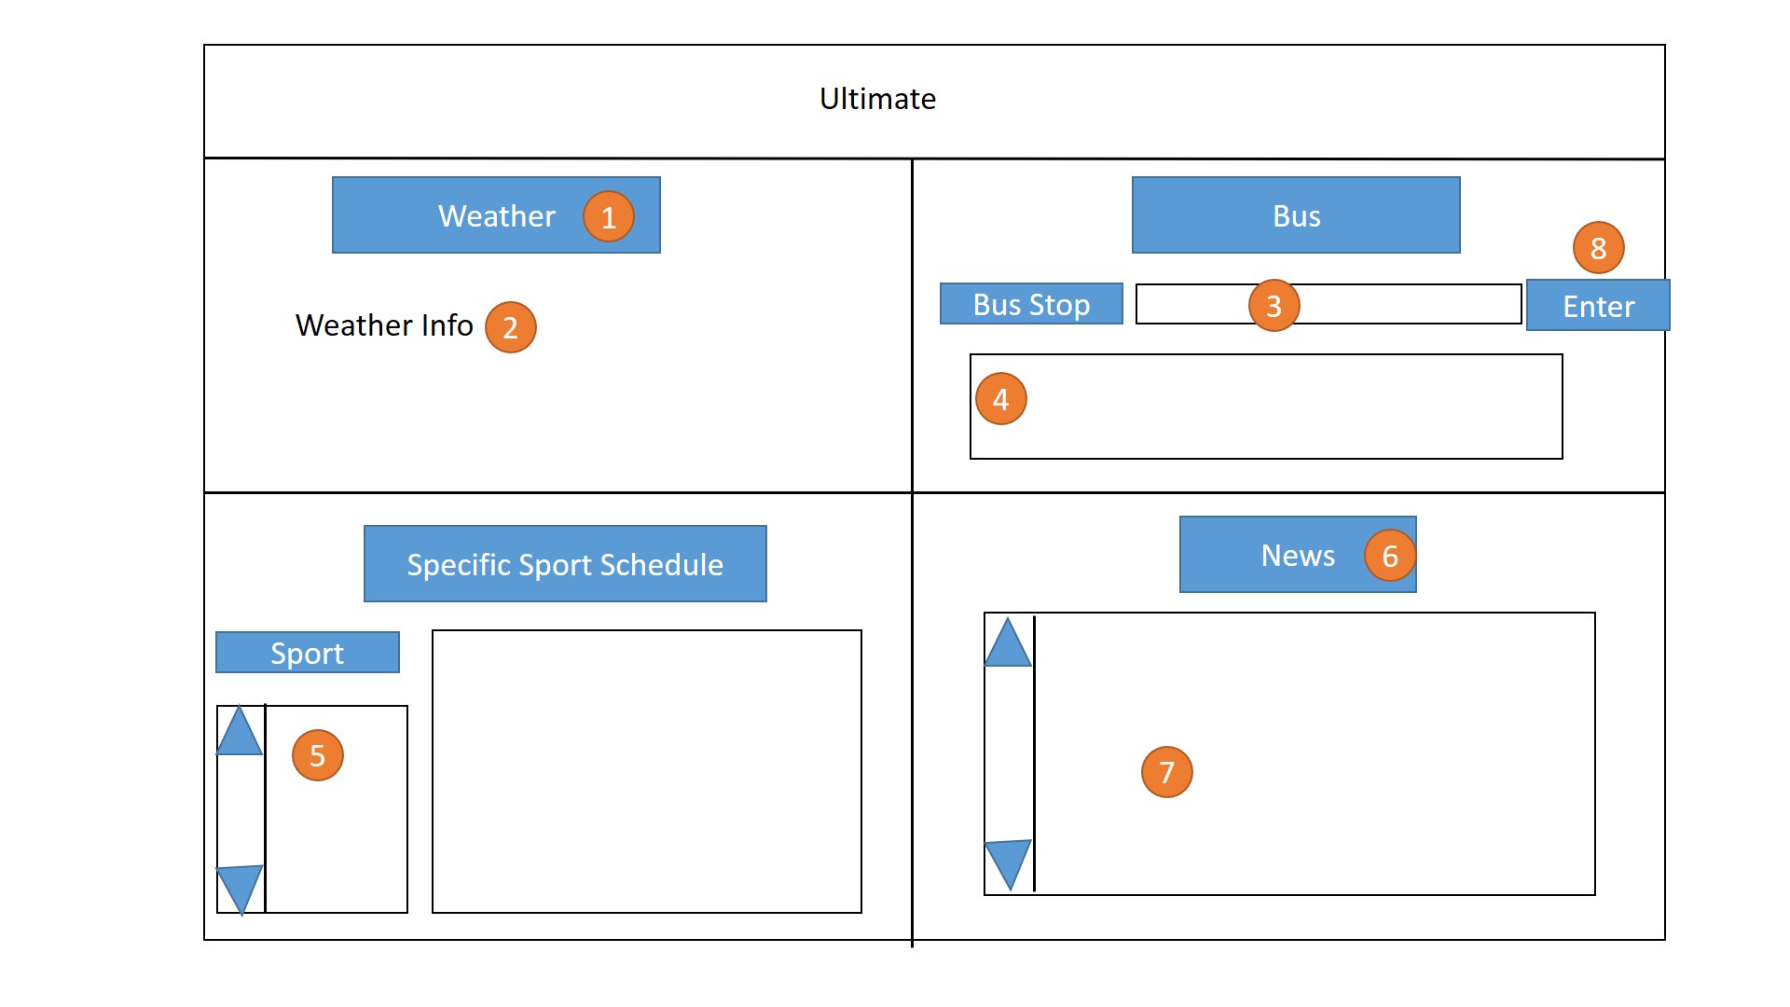

1. Weather refresh button: refresh the weather information by clicking it.

2. Weather information.

3. Place to write the Bus Stop

4. Prints the Bus schedule according to the Bus Stop(Number 3)

8. Refresh the Bus stop information according to the Number 3

5. A row down screen of the sports lists

6. The news refresh button to refresh the Newest News

7. A row down screen of the News, with the link that user can browse it by clicking it.

**Data Sources**

|  |  |
| --- | --- |
| Weather | Weather data will be retrieved from the Dark Sky weather API.  This API has a limit of 1,000 requests per day, with the option to sign up for a "pay as you use" model. |
| Sports | Sports event data will be retrieved from the cyclones.com RSS feed |
| ISU Events | Other (non-athletic) ISU event data will be retrieved from the iastate.edu calandar RSS feed(s) |
| Bus Data | CyRide data will be retrieved from the nextbus xml api. |
| News | News will either be retrieved from the iastate.edu news RSS feed, or possibly from the Iowa State Daily or Ames Tribune. This decision will be made at a later date depending on which option we determine to have more relevant/quality news articles. (A mix of multiple is not out of the question either). |

**Dependencies**

|  |  |
| --- | --- |
| Python v3.x | This application will be primarily written in Python3 |
| Requests | The Python requests package will be used to gather data from our various API's (these are outlined in the Data Sources section of this document). |
| ElementTree XML API | Used to parse XML responses from external API's |
| Feedparser | Used to parse RSS feed data (sports and ISU events) |
| Tkinter | Will be used to create user interface |
| pywin32 | Set of extension modules for accessing the Windows API. |

**Tasks:**

**Matt Thompson:**

Leader. Helper. Matt has the better understanding and skills of Python. Matt will lead the team to finish the code. Matt can interact any of the module. Matt will also be the helper to help the team members out.

**Keng Hu:**

Main_Interface Builder. Builds the main scripts.

**Liliane Iragena:**

Sport Builder

**Woo Voong:**

Weather, Bus, News Builder

**Nate Burger:**

Design and Documentation: Design the layout and provide documentation